# Topic 6 – Subqueries

## Familiarise yourself with the Human Resource (HR) schema from Oracle

Whereas in the lectures we use a small database consisting of only three table, for the labs we will be using the demo tables (schema) supplied by Oracle. The schema describes a human resources database used by a large multi-national company.

Use the Entity Relationship Diagram (ERD) below to familiarise yourself with the tables, relationships and attributes.

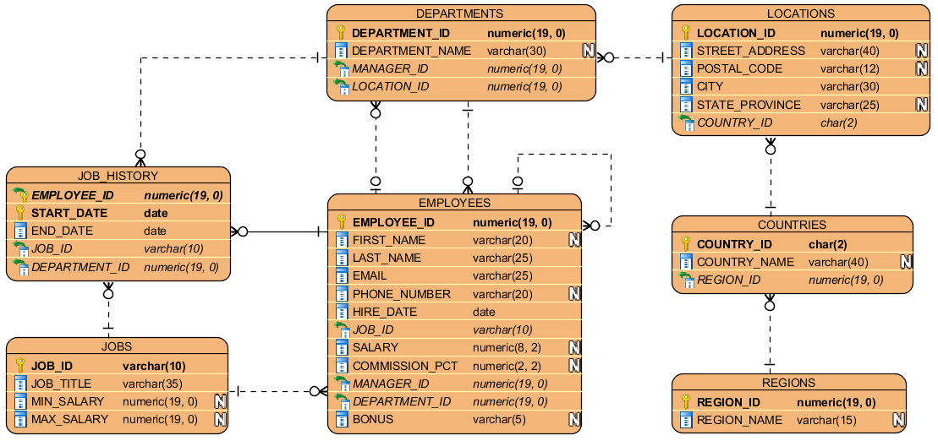

# Worked Examples

### Q1. List the employees earning more than the average for the company

The question asks us to return information about employees but only about some of them. When we want to only return some of the rows from a table we will use a WHERE clause. The difficult in this case is that the value we want to compare each row to is a function of all the rows. We therefore have to use a subquery which can calculate the average salary and record that for use with the WHERE clause.

To design our query we first use a placeholder for the average salary and imagine it was a known constant. If we had that, then the query is a simple SELECT, FROM, WHERE query:

SELECT first_name, last_name

FROM employees

WHERE salary > “average salary”;

Next, we design the query that would return the average salary. That is a simple group function, using the AVG function:

SELECT AVG(salary)

FROM employees;

Finally, to complete the query we insert the subquery inside brackets, replacing the placeholder:

SELECT first_name, last_name

FROM employees

WHERE salaray > (SELECT AVG(salary) FROM employees);

The result should be:  
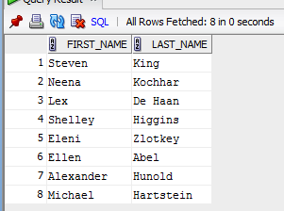

### Q2. List the employees earning more than the average for their department

Once again, the question asks us to filter the results using a value that must be calculated from many rows. We therefore have to use a subquery to calculate the average salary for a given department.

As before, we design our query in two steps. First, we design the outer query, using a placeholder for the WHERE clause:

SELECT first_name, last_name

FROM employees

WHERE salary > “average department salary”;

Next, we need to design the inner query, which, in this case, is the average salary of the employee’s department. The complicating factor is that we need to use information from the outer query inside the inner query. Specifically, we need to use the department_id from the outer query to limit the inner query to the average of employees in the same department. Using information from the outer query as part of the inner query is called a *correlated subquery*. Since the table in the inner query is the same as the outer query we will have to use aliases.

Assume we called the employees table in the outer query e1 then we can call the employees table in the inner query e2 and now we can write:

SELECT AVG(salary)

FROM employees e2

WHERE e1.department_id = e2.department_id;

Finally, we insert the inner query into the outer query in place of the placeholder and get:

SELECT first_name, last_name

FROM employees e1

WHERE salary > (SELECT AVG(salary)

FROM employees e2

WHERE e1.department_id = e2.department_id);

The result should be:

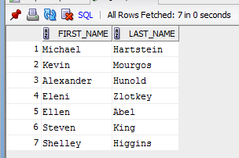

### Q3. List the employees earning more than the total of any other department

This question asks us to compare each employee’s salary to a collection of other values and return the row if the salary is greater than any of the values in the list provided. Again, we follow the same three-step process.

First, we design the outer query which is a little different in this case because of the list of values we expect back from the inner query. We want to return a row if salary is greater than any of the values so we use the ANY keyword:

SELECT first_name, last_name

FROM employees

WHERE salary > ANY (“totals for departments”);

Next, we design a query to return the total salaries in each department. Since we are reducing many rows down to a single row (the total) we know we need a group function. In this case, it is the SUM function to add up all the values. We also know that we need one row per department so we need to use GROUP BY. Therefore, the inner query is:

SELECT SUM(salary)

FROM employees

GROUP BY department_id;

In previous weeks, we have been careful to join the employees table with the departments table so that we could use department_name not department_id. But, in this case we don’t need to worry about that. The only reason we wanted to return department_name is because it has meaning to the user whereas IDs do not. But since the results from the inner query are not returned to the end user we do not need to be concerned with that.

Finally, we replace the placeholder in the outer query with our inner query and we get the final SQL:

SELECT first_name, last_name

FROM employees

WHERE salary > ANY (SELECT SUM(salary)

FROM employees

GROUP BY department_id);

The results should be:

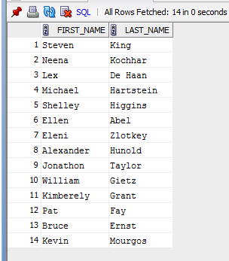

### Q4. List the employees whose salaries are within 10% of the average of the IT department

The question asks us to return some of the rows from the employees table, but the criterion for returning a row depends on information from many other rows. This is another case when we need a subquery. We follow our usual steps.

First, create the outer query with a placeholder. The placeholder will stand for the average salary of the IT department, but that still leaves us a bit of work to decide whether an employee’s salary is within 10% of that value or not. A straightforward way of making the comparison is to provide two checks: that the salary is less than 10% higher and less than 10% lower. We would therefore have:

SELECT first_name, last_name

FROM employees

WHERE salary <= “average it department” * 1.1

AND salary >= “average it department” * 0.9;

Next, we design the inner query, which is simply the average salary of employees in the IT department. We know this requires a group function – AVG. But we need to limit the rows that are included in the group function to only employees in the IT department. To do this a simple WHERE clause is sufficient:

SELECT AVG(salary)

FROM employees

INNER JOIN departments USING (department_id)

WHERE department_name = ‘IT’;

Finally, we need to insert the inner query into the outer query where the placeholders are. This is a straightforward process but in this case we would need to write out the subquery twice because we need the result of the subquery twice in the outer query.

To avoid this repetition we can use the WITH clause:

WITH average_it_department AS (

SELECT AVG(salary)

FROM employees

INNER JOIN departments USING (department_id)

WHERE department_name = ‘IT’)

SELECT first_name, last_name

FROM employees

WHERE salary <= (SELECT * FROM average_it_department) * 1.1

AND salary >= (SELECT * FROM average_it_department) * 0.9;

The result should be:

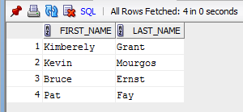

### Q5. List the employees whose salaries are below average but have worked at the company for more than the average

Once more, we know we will need a subquery because we want to filter rows based on information from multiple rows. The outer query requires two WHERE conditions, one for salary and one for the time worked at the company. Recall that to work out how much time has passed we use the MONTHS_BETWEEN function with SYSDATE. Therefore, the outer query would be:

SELECT first_name, last_name, salary,

ROUND(MONTHS_BETWEEN(SYSDATE, hire_date)) AS “Months Worked”

FROM employees

WHERE salary > “average salary”

AND MONTHS_BETWEEN(SYSDATE, hire_date) < “average time worked”;

Next, we need to design the subquery. We have two different placeholders in the outer query which might make us think we need to use two different subqueries. But in fact, if we think about it, we realise that both the average salary and average time worked can be calculated in the same subquery. Namely:

SELECT AVG(salary) AS avg_salary,

AVG(MONTHS_BETWEEN(SYSDATE, hire_date) AS avg_time_worked

FROM employees;

Notice that we gave aliases to the two calculated columns in the subquery. What we need to do now is insert the subquery into the outer query.

In this case, we need to use the subquery twice because we have two placeholders to replace. Therefore, like in the previous question, we can use the WITH clause to avoid writing it out twice:

WITH avg_sal_time AS (

SELECT AVG(salary) AS avg_salary,

AVG(MONTHS_BETWEEN(SYSDATE, hire_date)) AS avg_time_worked

FROM employees)

SELECT first_name, last_name, salary,

ROUND(MONTHS_BETWEEN(SYSDATE, hire_date)) AS “Months Worked”

FROM employees

WHERE salary > “average salary”

AND MONTHS_BETWEEN(SYSDATE, hire_date) < “average time worked”;

We haven’t quite finished because we need to replace the placeholders with the columns that are inside the subquery.

**NEW MATERIAL**

The trick here is that when we “access” the subquery, we do not need to take every column. In all previous examples there has been only one column in the subquery so we simply said SELECT * FROM subquery. In this case we have two columns and so we can specify which one we want on each line. This is why we provided convenient aliases for the columns.

The resultant SQL is:

WITH avg_sal_time AS (

SELECT AVG(salary) AS avg_salary,

AVG(MONTHS_BETWEEN(SYSDATE, hire_date)) AS avg_time_worked

FROM employees)

SELECT first_name, last_name, salary,

ROUND(MONTHS_BETWEEN(SYSDATE, hire_date)) AS “Months Worked”

FROM employees

WHERE salary > (SELECT avg_salary FROM avg_sal_time)

AND MONTHS_BETWEEN(SYSDATE, hire_date) <

(SELECT avg_time_worked FROM avg_sal_time);

The result should be:

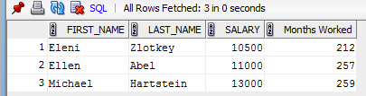

### Q6. List the employees who have the same manager and work in the same department as Curtis Davies (employee ID 142)

The question is asking us to filter rows based on information from the same table but on different rows, hence we need a subquery. Adopting the three-step process we first design the outer query. This is a straightforward SELECT and WHERE:

SELECT first_name, last_name, manager_ID, department_ID  
FROM employees  
WHERE manager_ID = “same as Curtis Davies”  
 AND department_ID = “same as Curtis Davies”;

Next, we design the subquery. In this case we have two to design, but they are simple queries:

SELECT manager_ID   
FROM employees  
WHERE employee_ID = 142;

and

SELECT department_ID  
FROM employees  
WHERE employee_ID = 142

Finally, we insert the subquery into the outer query in place of the placeholders:

SELECT first_name, last_name, manager_ID, department_ID  
FROM employees  
WHERE manager_ID = (SELECT manager_ID   
 FROM employees  
 WHERE employee_ID = 142)  
 AND department_ID = (SELECT department_ID  
 FROM employees  
 WHERE employee_ID = 142);

The result is:

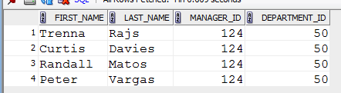

**NEW MATERIAL**

In this example, we have two subqueries and both use the same condition (“WHERE employee_ID = 142”). Not only that, both are used with the same condition outside of them in the outer query (“=”). In this kind of situation we can combine them into a single subquery which will return a list of values. In this case the list would be manager_ID and department_ID. We can then combine the two values in the outer query into a list and compare one list to the other.

To make the manager_ID and department_ID into a list, we place them in brackets as a comma-separated list. The reworked query is:

SELECT first_name, last_name, manager_ID, department_ID  
FROM employees  
WHERE (manager_ID, department_ID) =   
 (SELECT manager_ID, department_ID   
 FROM employees  
 WHERE employee_ID = 142);

We can use this whenever we have multiple subqueries that are essentially the same (i.e. retrieve the same set of rows) and when the comparison to the subqueries are the same (i.e. both =, or IN etc).

# Completion Problems

### Q1. List the employees who earn more than the average salary in every department.

A: SELECT first_name, last_name, salary   
FROM employees   
WHERE salary > ALL (SELECT AVG(salary) FROM employees

INNER JOIN departments USING(department_id)

GROUP BY dep_id);

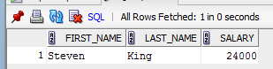

### Q2. List the employees who have worked at the company for longer than the average.

A: SELECT first_name, last_name   
FROM employees   
WHERE MONTHS_BETWEEN(SYSDATE, hire_date) > (SELECT AVG(MONTHS_BETWEEN(SYSDATE, hire_date)) FROM employees);

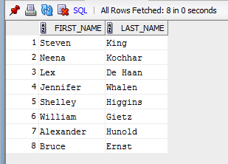

### Q3. List the employees where the length of their department name is below average.

A: SELECT first_name, last_name, department_name   
FROM employees   
INNER JOIN departments USING (department_ID)   
WHERE LENGTH(department_name) < (SELECT AVG(LENGTH(department_name)) FROM departments);

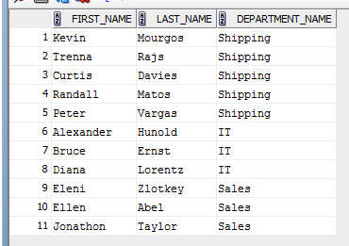

### Q4. List the departments where the department’s manager’s first name is longer than the average first name in that department.

A: SELECT department_name, first_name AS "Manager Name", length(first_name) AS "Name Length"  
FROM departments d1   
INNER JOIN employees ON d1.manager_id = employees.employee_id   
WHERE length(first_name) > (SELECT AVG(length(first_name))   
 FROM employees e2  
 INNER JOIN departments d2 ON e2.department_ID = d2.department_ID  
 WHERE d1.department_name = d2.department_name)   
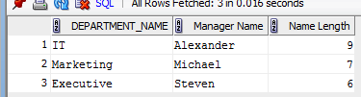

### Q5. List the departments where the average salary in that department is greater than 5000.

A: SELECT department_name, ROUND(AVG(salary),2) AS "Average Salary"   
FROM employees   
INNER JOIN departments USING (department_id)  
GROUP BY department_name   
HAVING AVG(salary) > 5000;

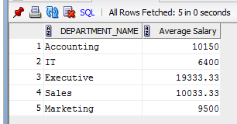

### Q6. List the departments whose average salary is above the average of all employees.

A: SELECT department_name, ROUND(AVG(salary),2) AS “Average Salary”   
FROM employees   
INNER JOIN departments USING(department_id)   
GROUP BY department_name

HAVING AVG(salary) > (SELECT AVG(SALARY) FROM EMPLOYEES);

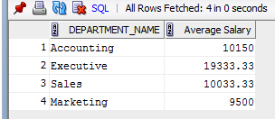

### Q7.List the employees whose salary is greater than the average salary among employees whose surnames end in the letter ‘s’.

A: SELECT first_name, last_name, salary   
FROM employees   
WHERE salary > (SELECT AVG(salary) FROM employees WHERE last_name LIKE ‘%s’);

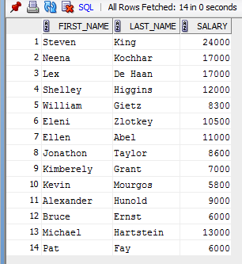

### Q8. List all the employees and their bonuses. For those without a bonus, show the average bonus instead.

A: SELECT First_name, last_name,   
 NVL(bonus,(SELECT ROUND(AVG(bonus), 2) FROM employees)) AS Bonus  
FROM Employees;

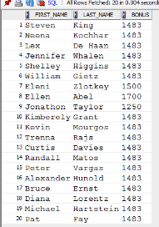

# Deliberate Practice: Write the SQL

### Q1. List the employees earning more than the mid-range for their job.

SELECT first_name, last_name, salary, max_salary, min_salary

FROM employees

INNER JOIN jobs USING(job_id)

WHERE salary > (max_salary+min_salary)/2;

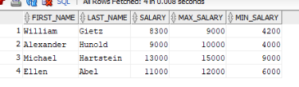

### Q2. List the employees earning the most in each department.

SELECT first_name, last_name, department_name, salary

FROM employees

INNER JOIN departments USING(department_id)

WHERE salary = ANY (SELECT MAX(salary)

FROM employees

GROUP BY department_id);

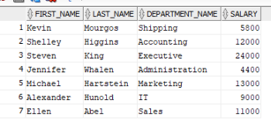

### Q3. For each telephone group (i.e. they share the same first six digits), give the average salary of the group.

SELECT SUBSTR(phone_number,1,7), ROUND(AVG(salary),2)

FROM employees

GROUP BY SUBSTR(phone_number,1,7)

HAVING SUBSTR(phone_number,1, 7) = ANY(SELECT SUBSTR(phone_number,1,7)

FROM employees);

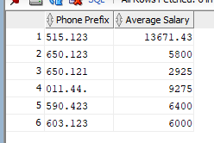

### Q4. List the average salary of departments whose average is above the company-wide average

SELECT department_name, AVG(salary)

FROM employees

INNER JOIN departments USING(department_id)

GROUP BY deparment_name  
HAVING AVG(salary) > (SELECT AVG(salary)

FROM employees);

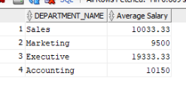

### Q5. List the employees earning more than a third of their manager’s salary.

SELECT e.first_name, e.last_name, e.salary, m.salary

FROM employees e

INNER JOIN employees m

ON e.manager_id = m.employee_id

WHERE e.salary > m.salary/3;

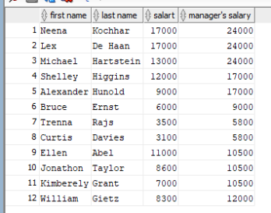

### Q6. CHALLENGE! List, for each employee, what their annual salary would be if they received an end of year bonus equal to the average of the bonuses paid out to those who receive them.

SELECT first_name, last_name, ROUND(salary*12 + (SELECT AVG(bonus) FROM employees),2) AS "New Annual Income"

FROM employees;

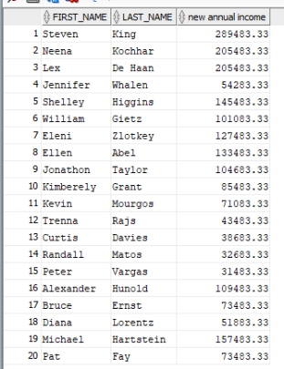

### Q7. CHALLENGE! List the employees earning the most of those hired in the same year as they were.

SELECT first_name, last_name, salary, hire_date

FROM employees

WHERE salary = ANY(SELECT MAX(salary)

FROM employees

GROUP BY EXTRACT(YEAR FROM hire_date));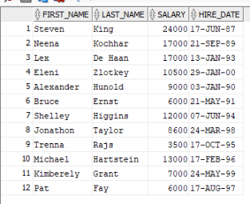

### Q8. CHALLENGE!! List the top three departments with the highest spread of actual wages

SELECT department_name, SUM(salary)

FROM departments

INNER JOIN employees e1 USING(department_id)

GROUP BY department_name

ORDER BY (SELECT MAX(salary) – MIN(salary) FROM employees e2

WHERE e1.department_id = e2.department_id) DESC

FETCH FIRST 3 ROWS ONLY;

